3rd problem screen shots

1. In case of palindrome 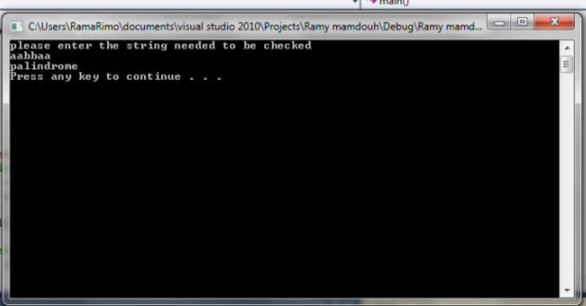

2. in case of not palindrome

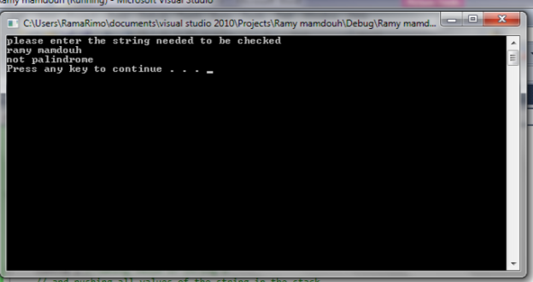

Code : #include<iostream>

#include<cstring>

#include<string>

using namespace std ;

int const size = 80; //size of the stack

char thestack[size] ;//stack of charachters

int top= -1 ;

bool isfull()

{

if(top==size-1)

{ return true ;

}

return false ;

}

bool isempty()

{

if(top==-1)

{

return false ;

}

return true ;

}

char pop() //removing element from the stack

{

return thestack[top--] ;

}

void push (char element )//putting a charchter in the stack

{

if(!isfull())

{

thestack[++top]=element ;

}

}

void main()

{

string a ;

string b=" " ;

int count=0 ;

cout<<"please enter the string needed to be checked "<<endl ;

cin>>a ; //taking value of string a

// and pushing all values of the string in the stack

for(int i= 0 ; i<a.length();i++)

{

push(a.at(i)) ;

}

//popping all elements in another string

for(int j =0 ; j<a.length();j++)

{

b.at(j)=pop() ;

}

//comparing every element in stack 'a' to every element in stack 'b'

for(int k= 0; k<a.length() ;k++)

{

if(a.at(k)==b.at(k))

{

count++;//increasing the variable count if the elements in two strings are equal

}

else

{

cout<<"not palindrome "<<endl ;//if compiler found two element not equal compiler will dipslay not palindrome and will go outside of the for loop

break;

}

}

//if he found all are the same and count equal the same number of elements in string'a' compiler will display palindrome

if(a.length()==count)

{

cout<<"palindrome "<<endl ;

}

system("pause") ;

}